Bài 2 – Lab7:
https://docs.google.com/forms/d/e/1FAIpQLSdxG4br7_LVKcDEa96ErXZSQnmBM681bL0GTppRJBAfoNWBjA/viewform\
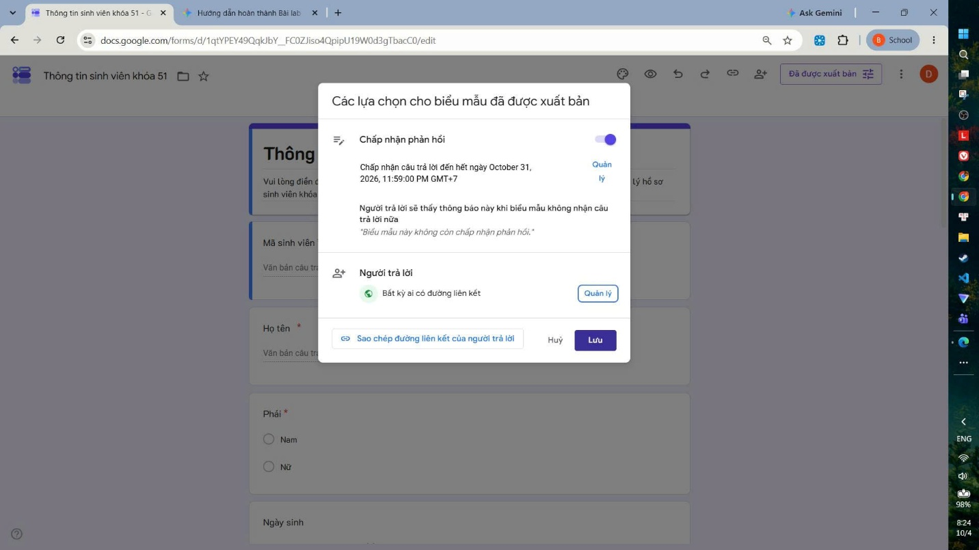 https://docs.google.com/forms/d/e/1FAIpQLScMyw0jNYgdkhtO5SpAr_gdhJXt-CcqeNfxnuz0L0T0CdVxRQ/viewform